Professional Readiness Program for

**Innovation,**

**Employability and**

**Entrepreneurship**

***SMART HOME***

***submitted by***

***J.F.Jenisha***

***961819106025***

***Electronics and Communication Engineering***

***Ponjesly College of Engineering***

INTERNET OF THINGS-B12-6A2E

***GLOWING LIGHT USING PIR SENSOR***

***CODE:***

// C++ code

//Blink-makes a single LED blink on and off

void setup()

{

Serial.begin(9600);

pinMode(4,INPUT);

pinMode(13,OUTPUT);

}

void loop()

{

int p=digitalRead(4);

Serial.println(p);

if(p)

digitalWrite(13,HIGH);

else

digitalWrite(13,LOW);

delay(1000);

}

**TINKERCAD LINK:**

<https://www.tinkercad.com/things/cSUVqfqxQiW-glorious-leelo/editel?sharecode=bvNCefCPz0BSjw2trDRUJwRCi9qsh9rsL443ESpFXY0>

**FIGURE:** 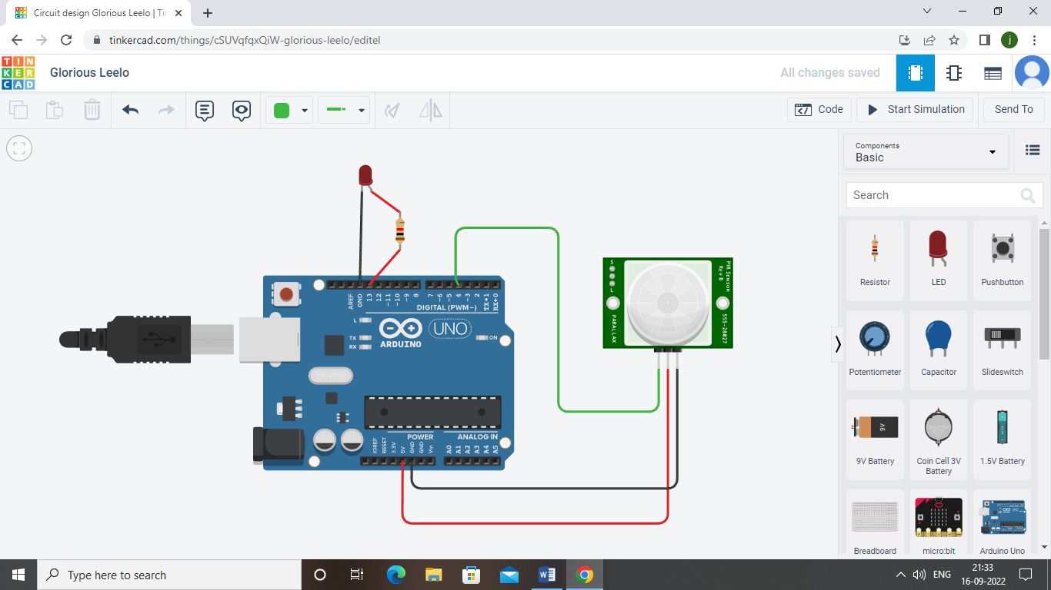

Two components are connected to the aurdino PIR sensor is used to detect the motion of the sensor and when the motion is detected the LED starts to glow.